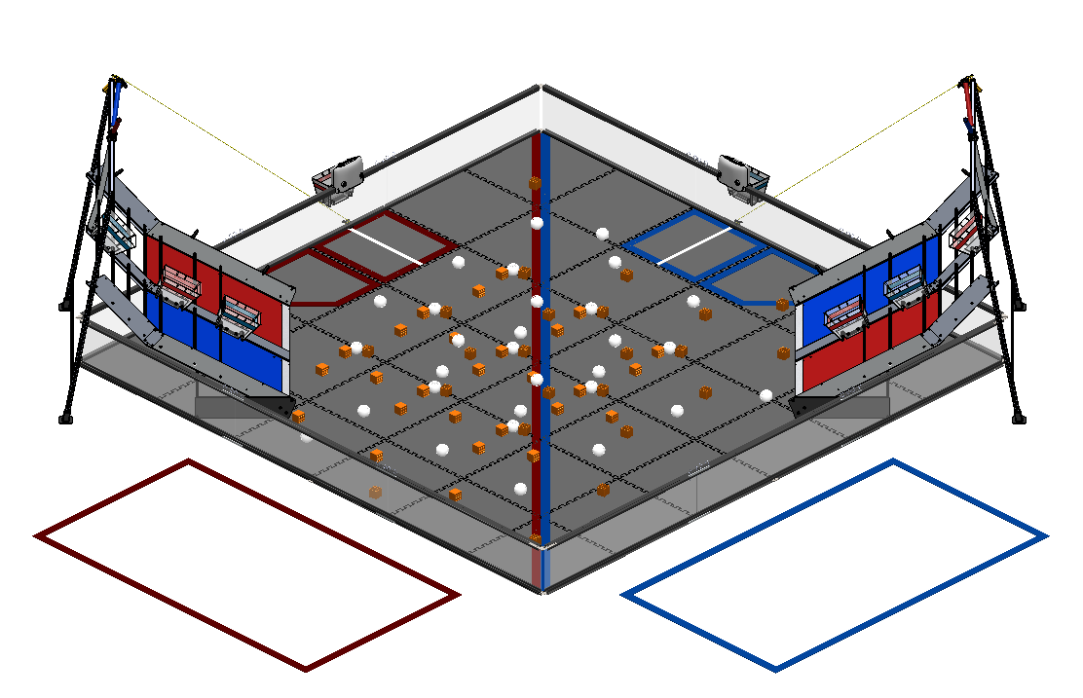
F.T.C. 2015-16

“Res-Q”

Team 452 PHI Alpha
Hardware Log

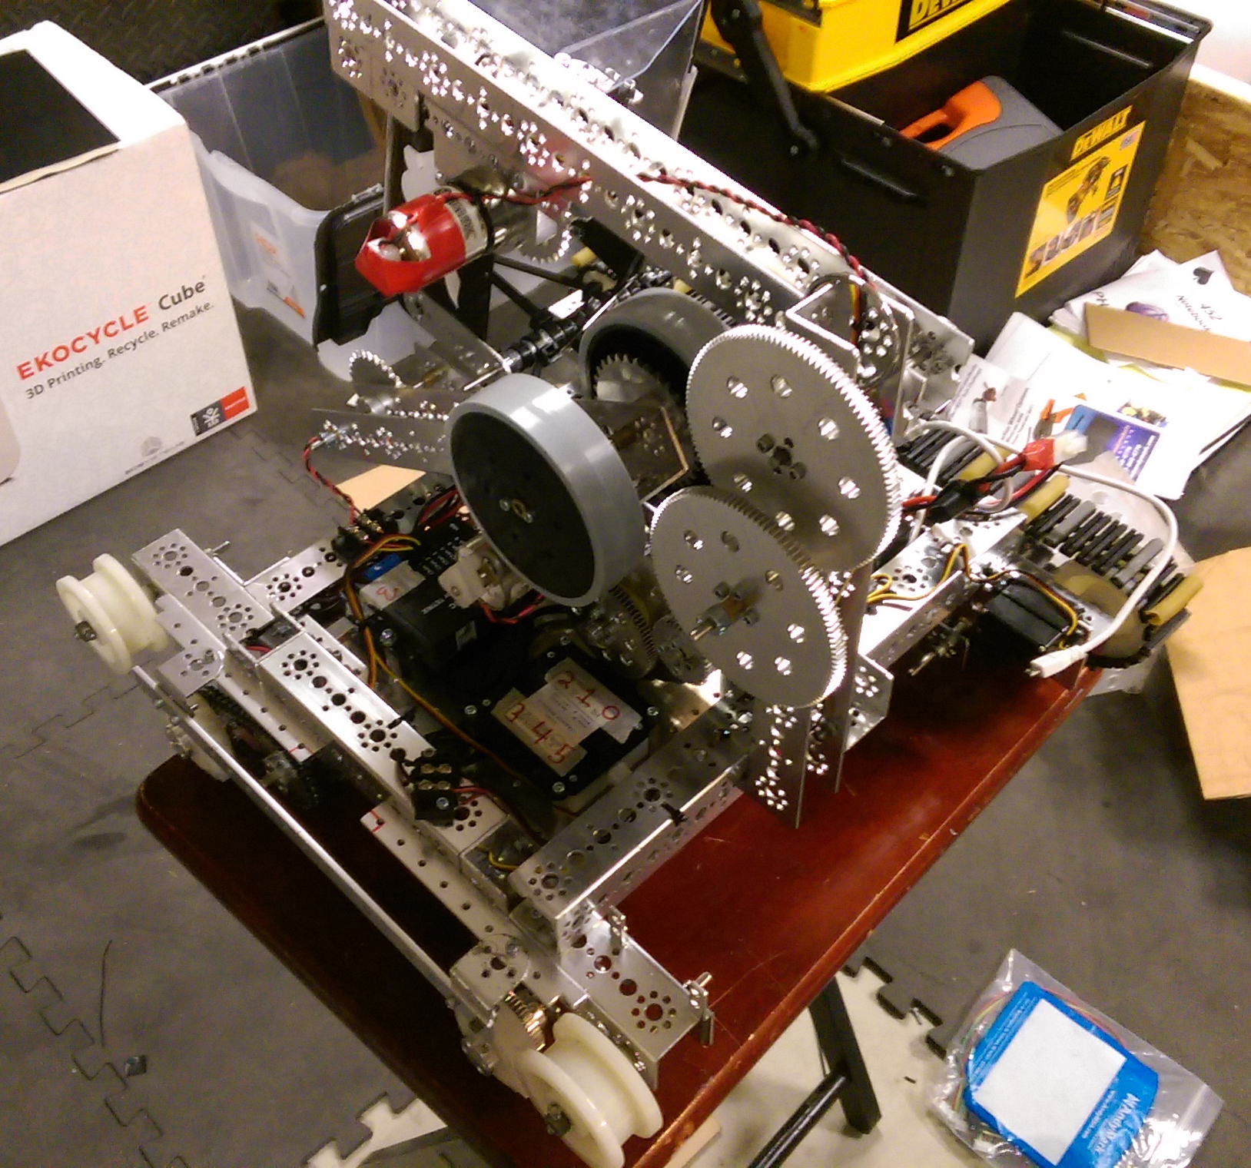
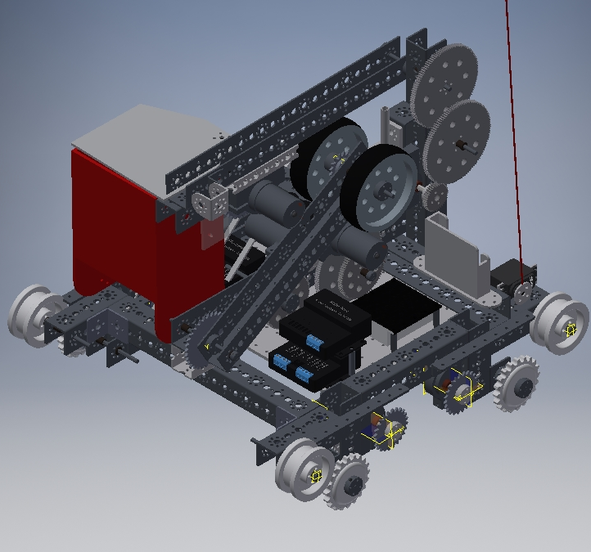
“Two-Face”

Our robot, given the name of “Two-Face”, is the one of the first tread driven robots that our team has ever built. In the past, our team has used wheels for our drive train, but this year we decided that tread may be more effective. Our robot is built of primarily Tetrix metal parts, but we do have some custom made pieces.
Two-Face has several functions. On the front of the robot, there is an intake assembly that is used for picking up balls and blocks to score in the mountain buckets. On the rear, we designed and built a powered wheelie bar, or tail, to keep the robot stable while climbing the mountain during the match, as well as during the end game.
A servo is mounted on the front left corner of the robot, which is attached to a carbon fiber rod. This is a little device we call the whip, which, along with a lift winch, is used during the end game to hang the robot.

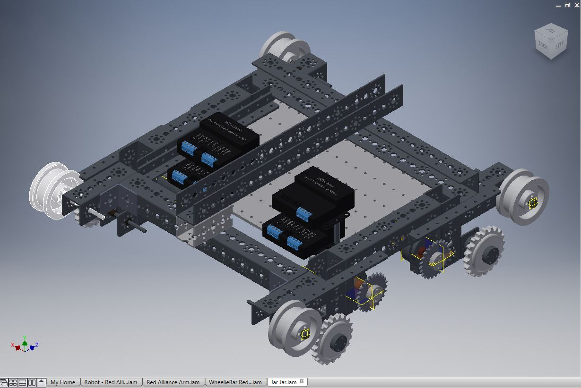
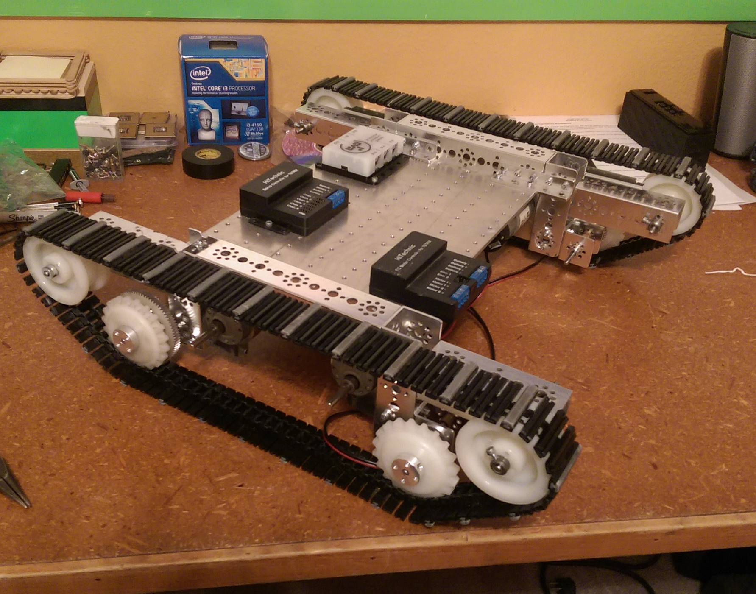
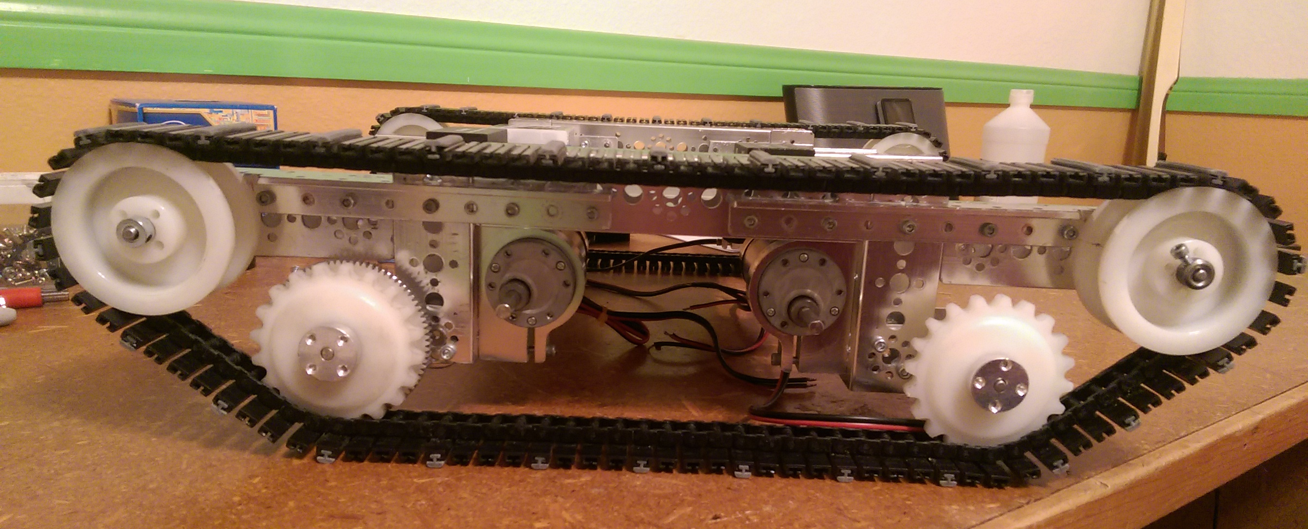
Drive System And Chassis

Two-Face's chassis and drive system is built around a central mounting plate. Attached on either side of the plate are an assembly of Tetrix parts that make up the tread system. The motors are mounted underneath the plate, to give a low COG and more mounting space on the surface of the robot. The front and back of the tread is built at an angle so that we can drive up and over the mountain churros.
The design has potential for four motor drive, but we currently only have it set up for two wheel drive. The reason for this is because less motors makes the robot lighter, and with this drive system, four motors did not seem necessary.
In the past, our robots have had a problem with the drive train bowing out with extended use. This robot is built to resist that. The combination of the central plate and use of angle beams keeps the robot square and straight.

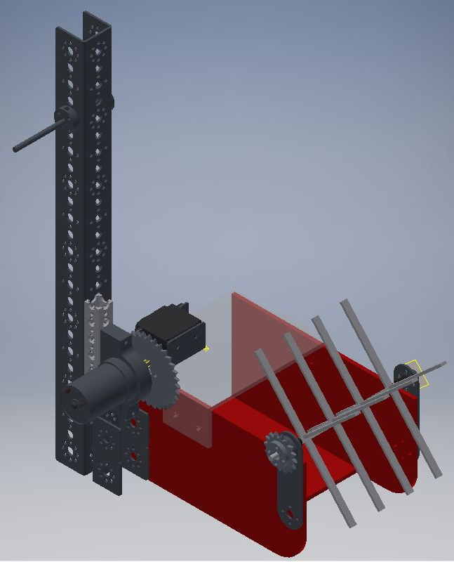
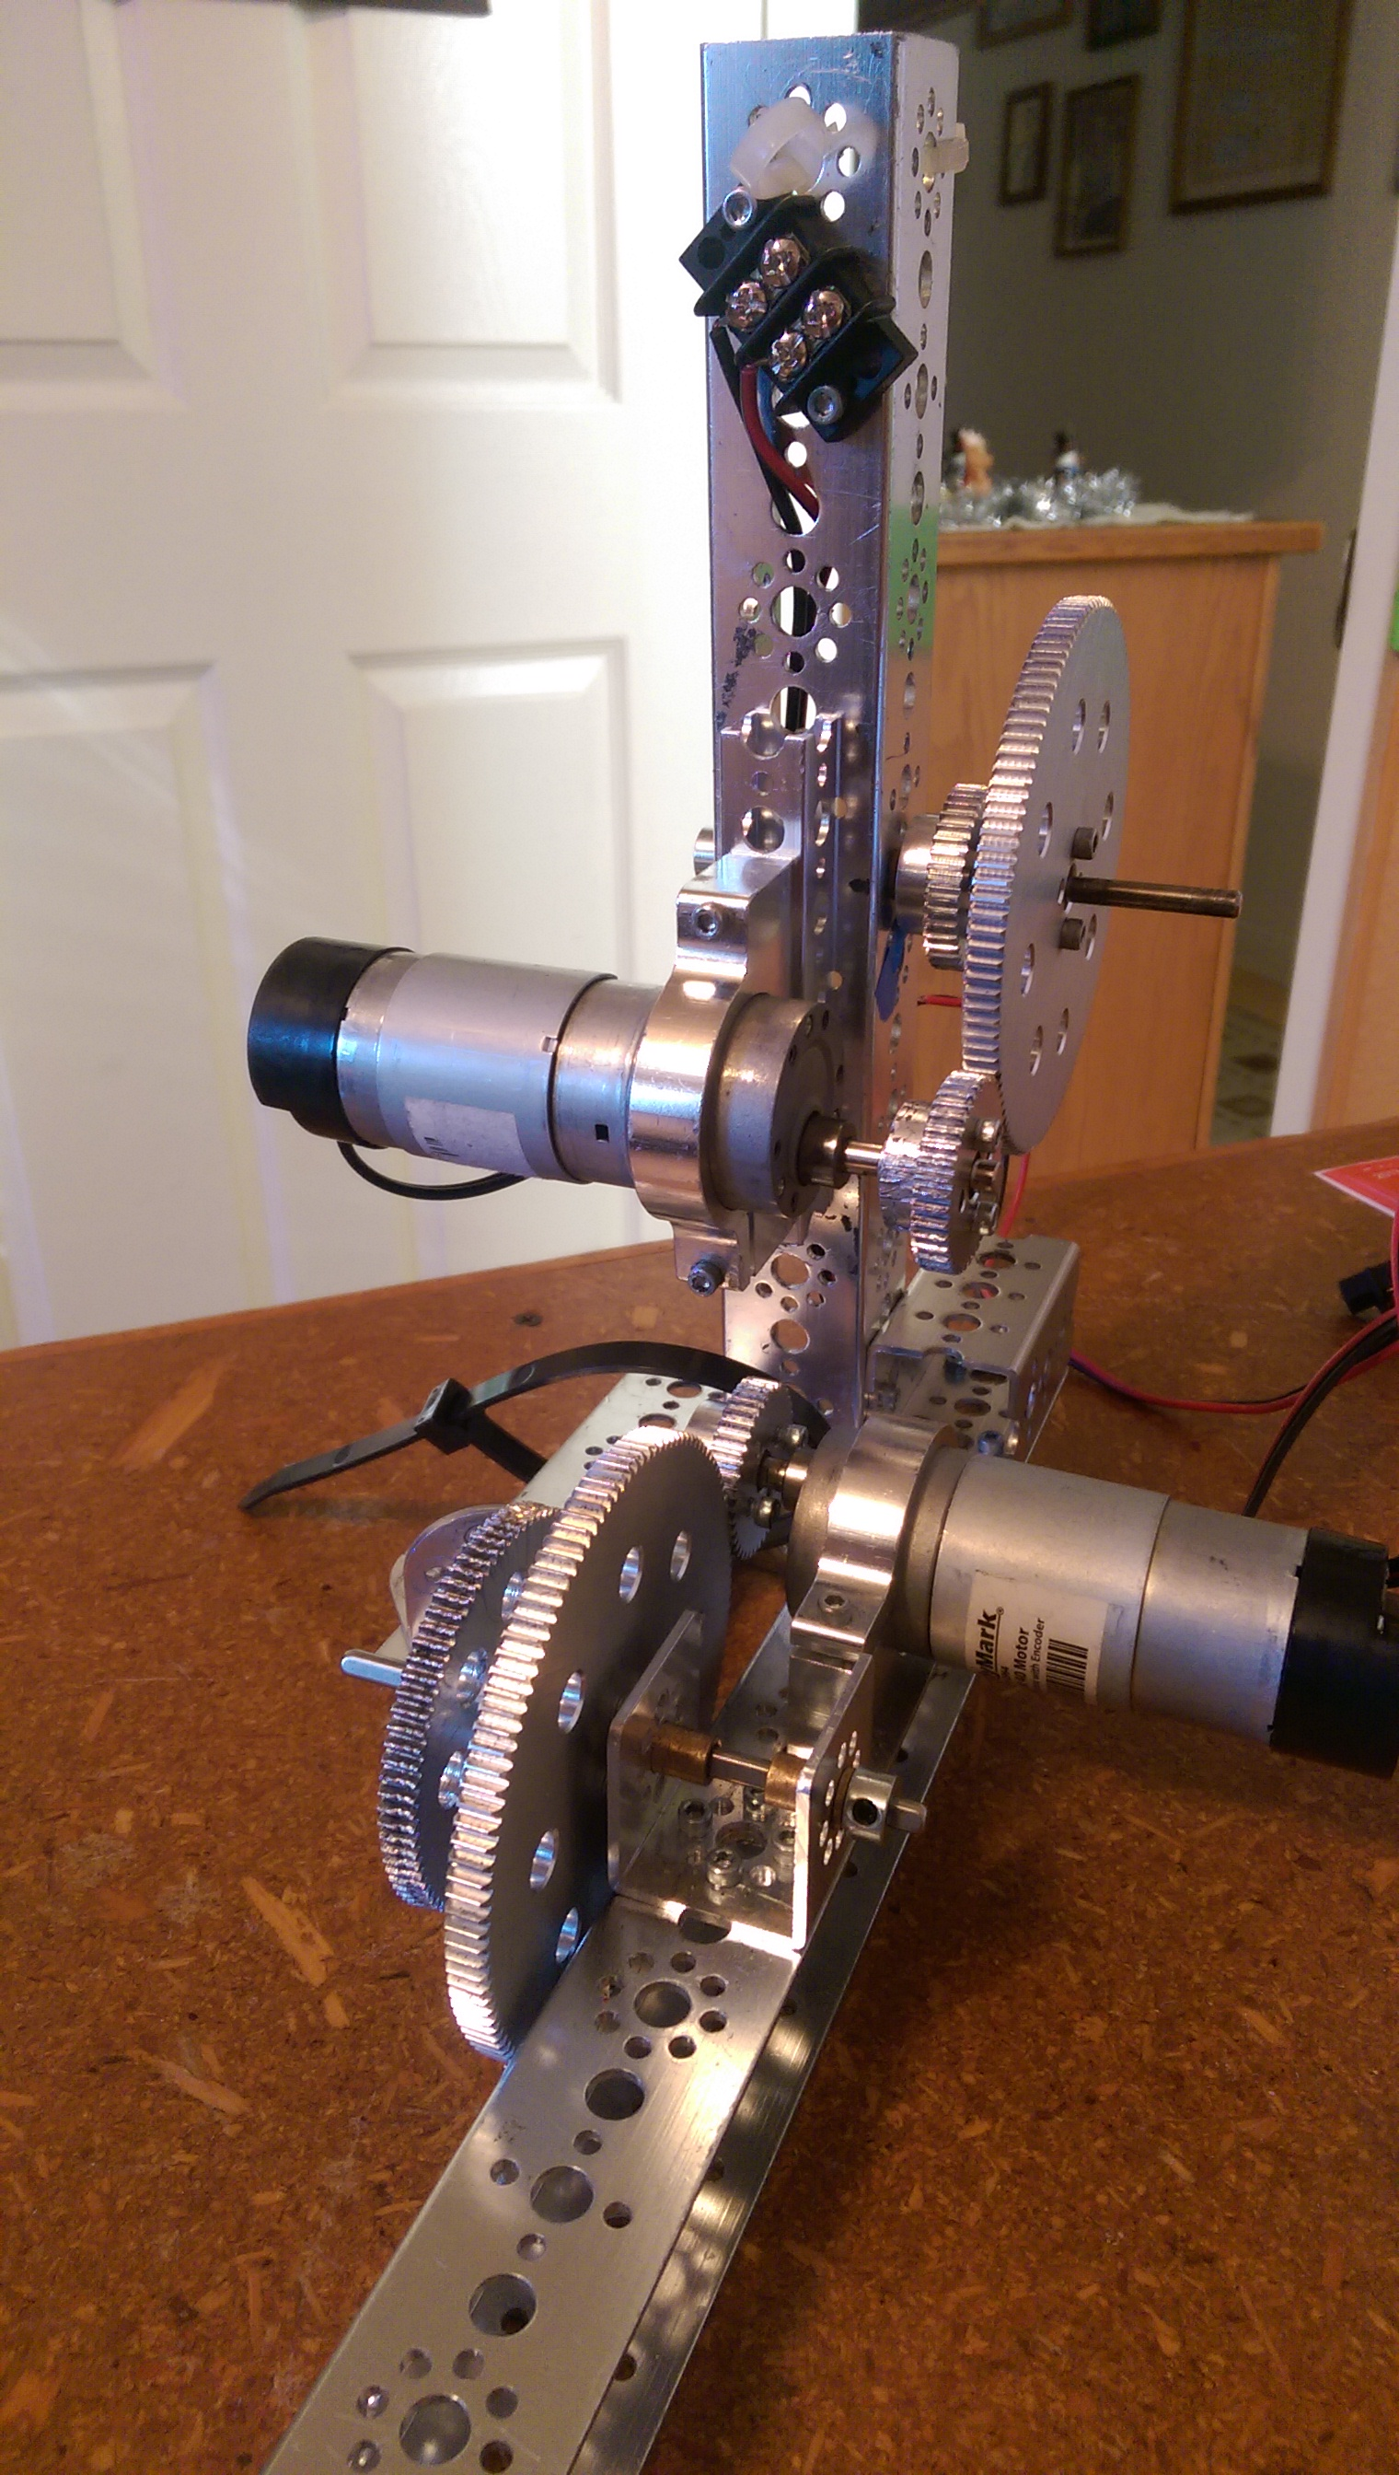
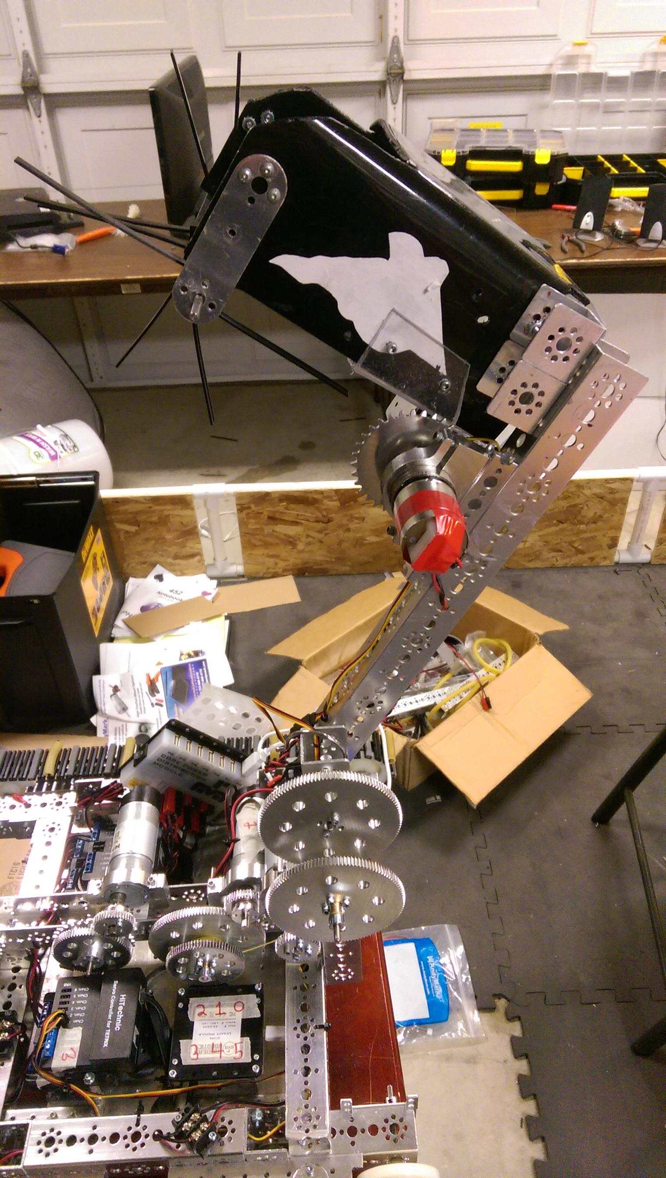
The T-Rex Arm

This arm is used during the two minute driver period to pick up and score the blocks and balls into the mountain goals. The arm has two main parts. There is the gear system for rotating the arm up and down, and on the end of the arm is the bucket.
The gear system is powered by an AndyMark motor, and has an approximate torque gear ratio of 8 to 1. We originally started out with a smaller gear ratio of 4 to 1, but the robot arm would slowly drop while we drove, and made scoring and maneuvering around the field difficult. Our current gearing allows for precise control of the arm, and is much easier to use.
The bucket has been built to hold 4 field elements. On the front there is a powered rake that spins and sweeps elements from the field floor into the bucket. This rake is powered by a Tetrix motor connected via chain. On the rear of the bucket is a trapdoor powered by a servo. When the bucket is aligned on top of a mountain goal, the trapdoor will open and the contents fall into the goal.

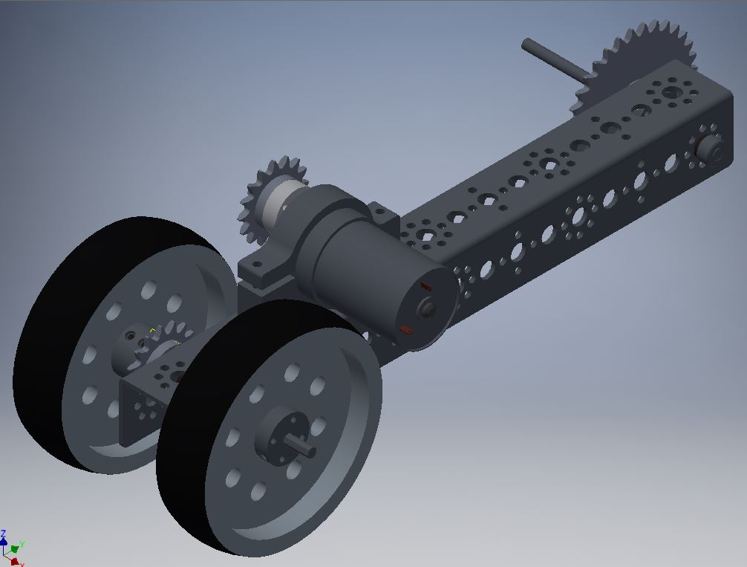
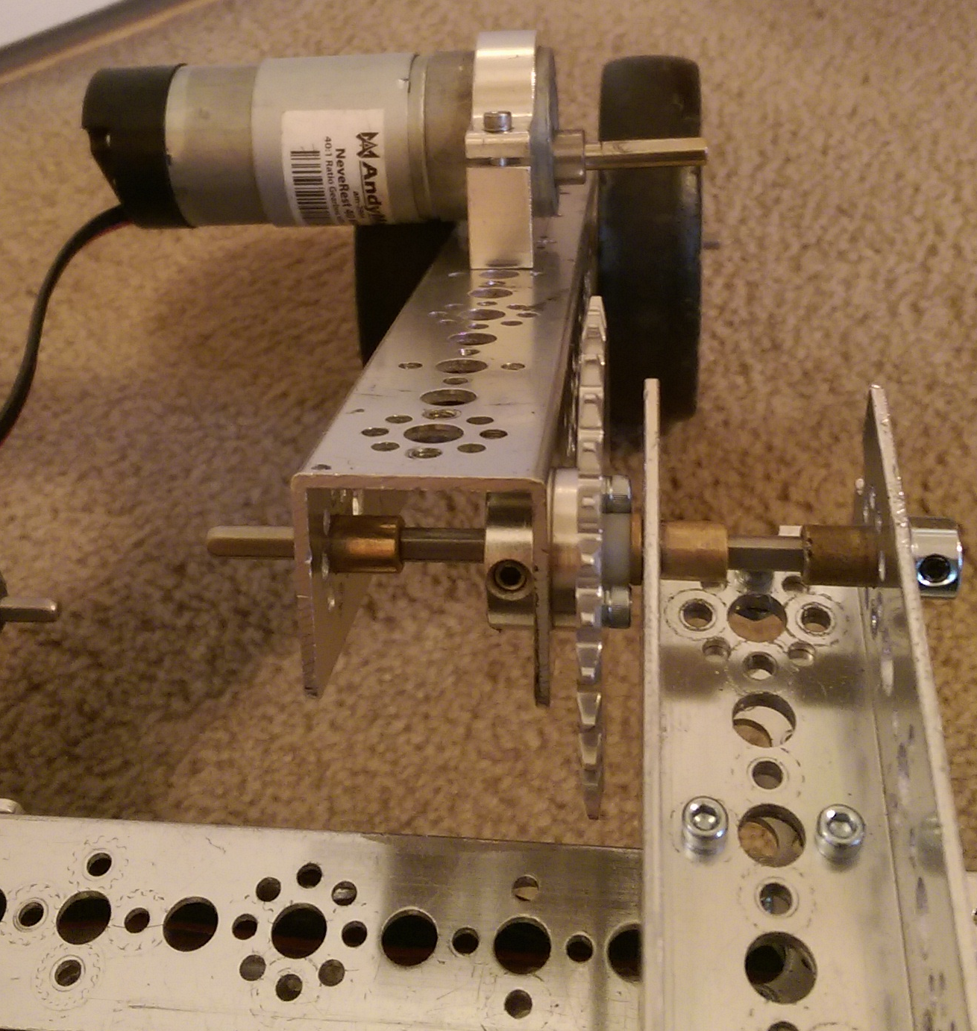
The Tail (or Wheelie Bar)

The Tail is a wheelie bar assembly mounted on the back of the robot. Its designed purpose is to keep the robot balanced while climbing the ramp, as well as give it an extra point of contact while climbing. The tail consists of a beam with a powered wheel at the end, and its pitch is controlled by a second motor mounted in the center of the chassis. The drive motor is geared for torque, to give more power to the robot to climb. The wheels are AndyMark High Grip wheels, which have more traction on the slick ramp than the traditional Tetrix wheel.

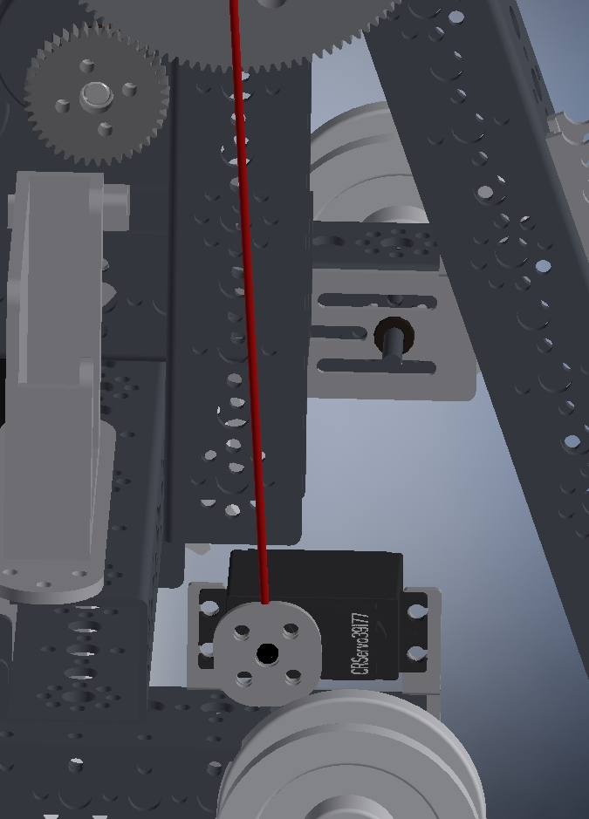
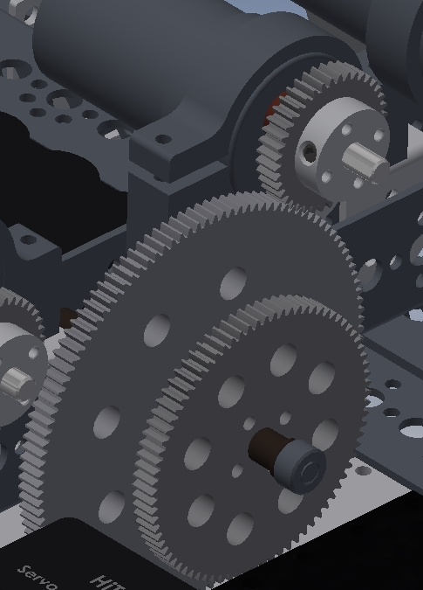
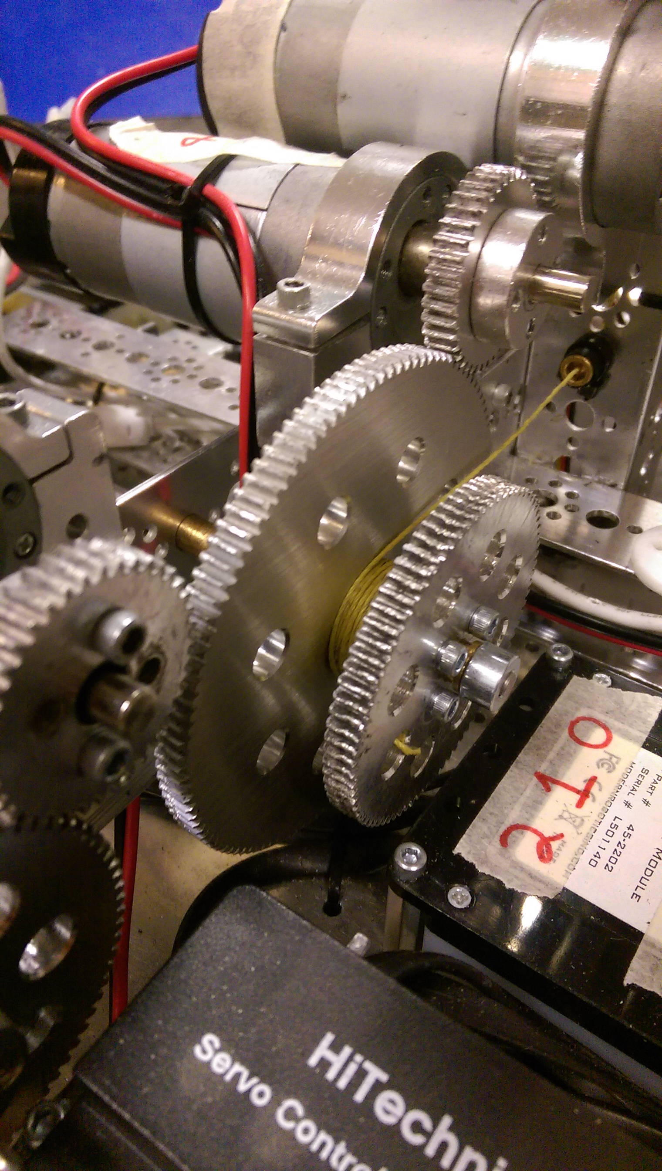
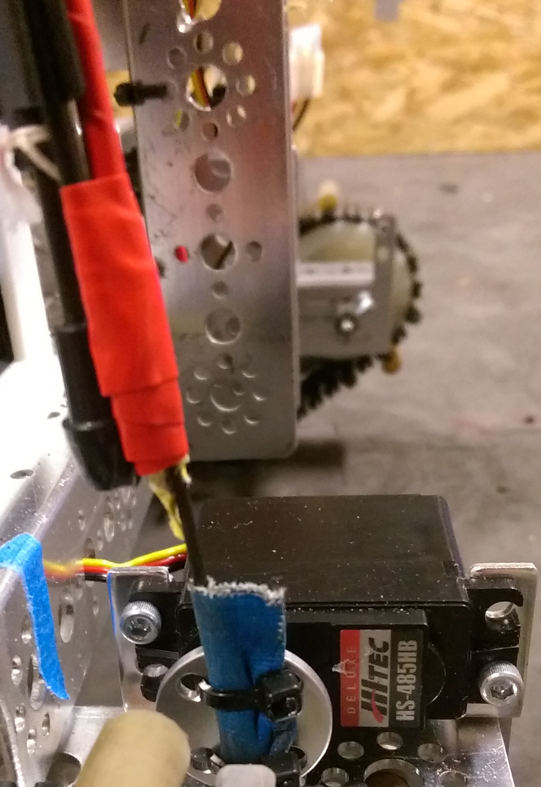
The Wicked Whip of the Left (The Whip)

During the last 30 seconds of the driver period is the End Game. The challenge for this part of the game is to climb the mountain and hang the robot from the pull up bar. Our solution to this challenge consists of a two part system. One part is a lift winch, placed in the center of the robot, and the other is a 3 foot long carbon fiber rod connected to a servo. This “whip” starts the match in a coil on the side of the robot, with a hook taped on the end.
Tied to that hook, is a string of Kevlar thread that follows along the rod down into the robot, and is tied on the opposite end to the lift winch. The thread is attached to the whip with masking tape at the beginning of the match, to prevent the thread from getting tangled in the robot. The thread then runs along the front of the chassis to a hole that lines it up with the middle of robot, where it is then tied to the winch spool.
During the End Game, the robot will climb the ramp, and the servo will release the whip. The desired outcome is that the hook on the end of the rod will line up with the pull up bar. When this happens, the lift winch will spool up the thread and begin to lift the robot all the way until it is elevated off the mountain surface, and is suspended in the air by the thread and winch. During this process, the tape attaching the carbon fiber rod to the hook and thread will rip, and prevent the rod from breaking.
This system is built that if the robot is not lined up correctly the first time, or misses its mark, we can bring the carbon fiber rod back and try again until we are successful.

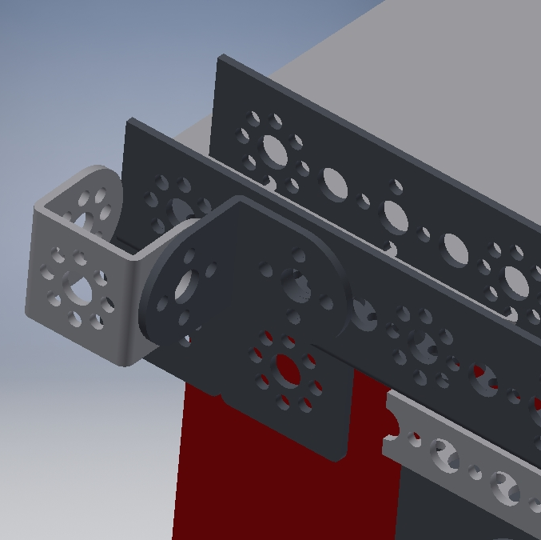
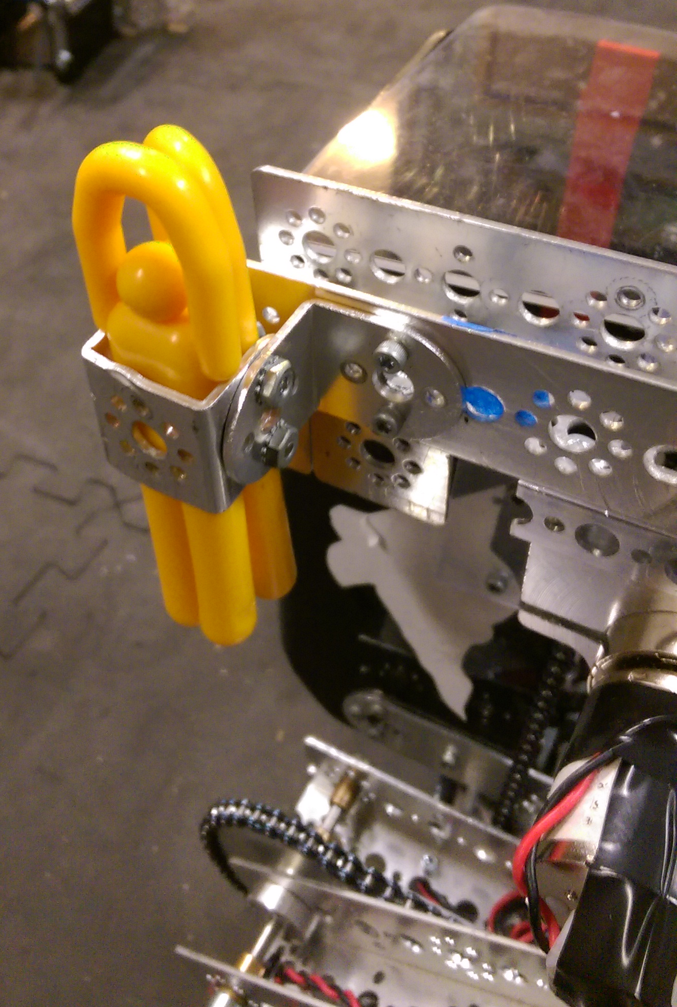
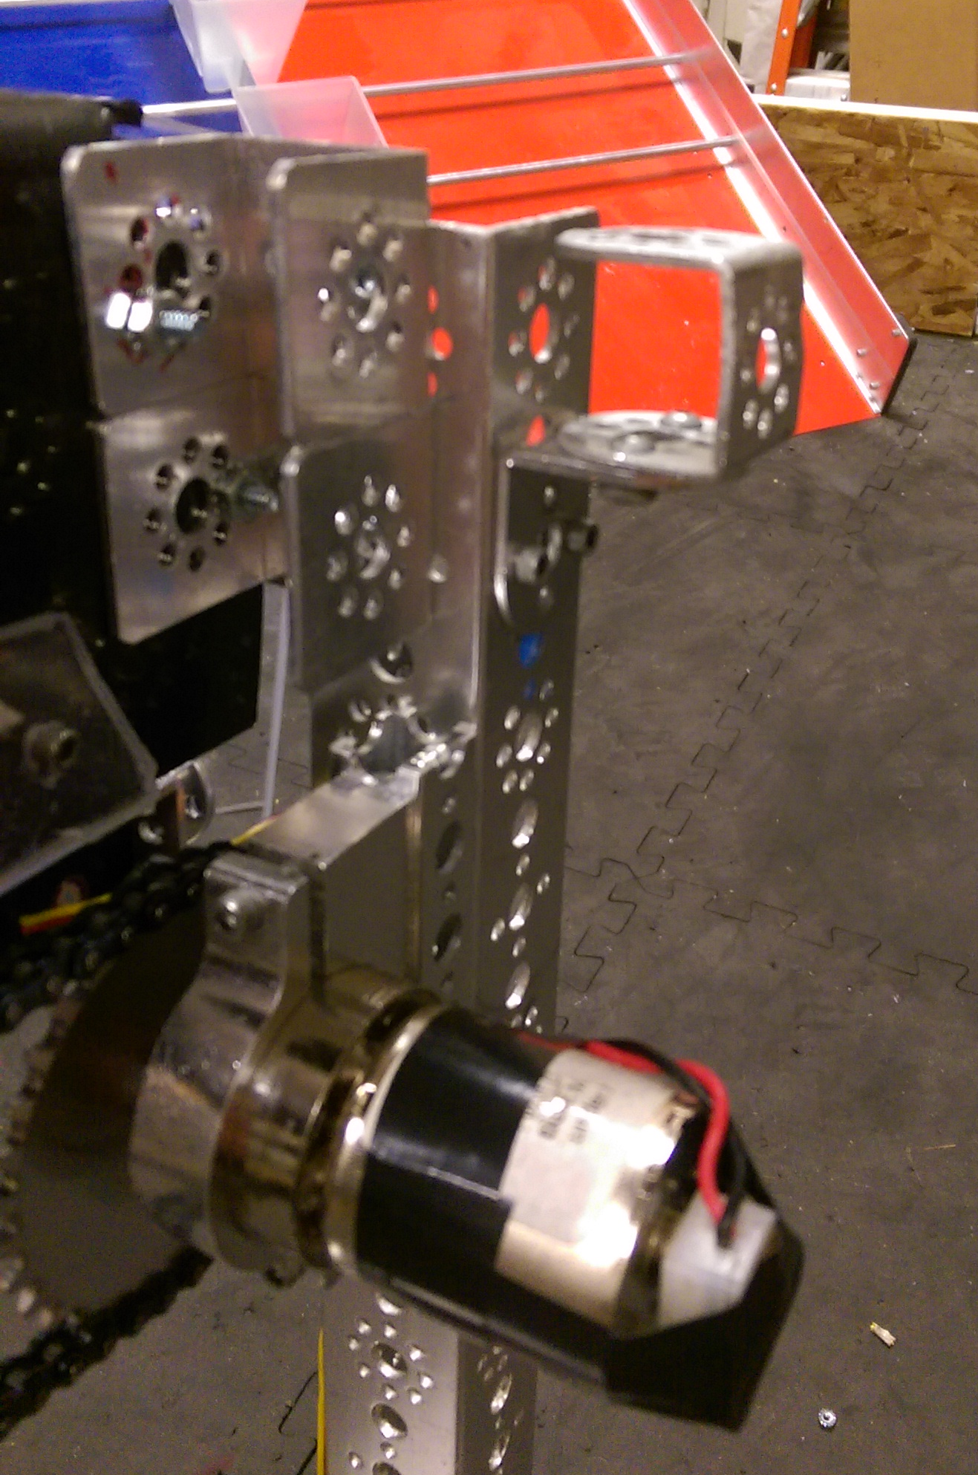
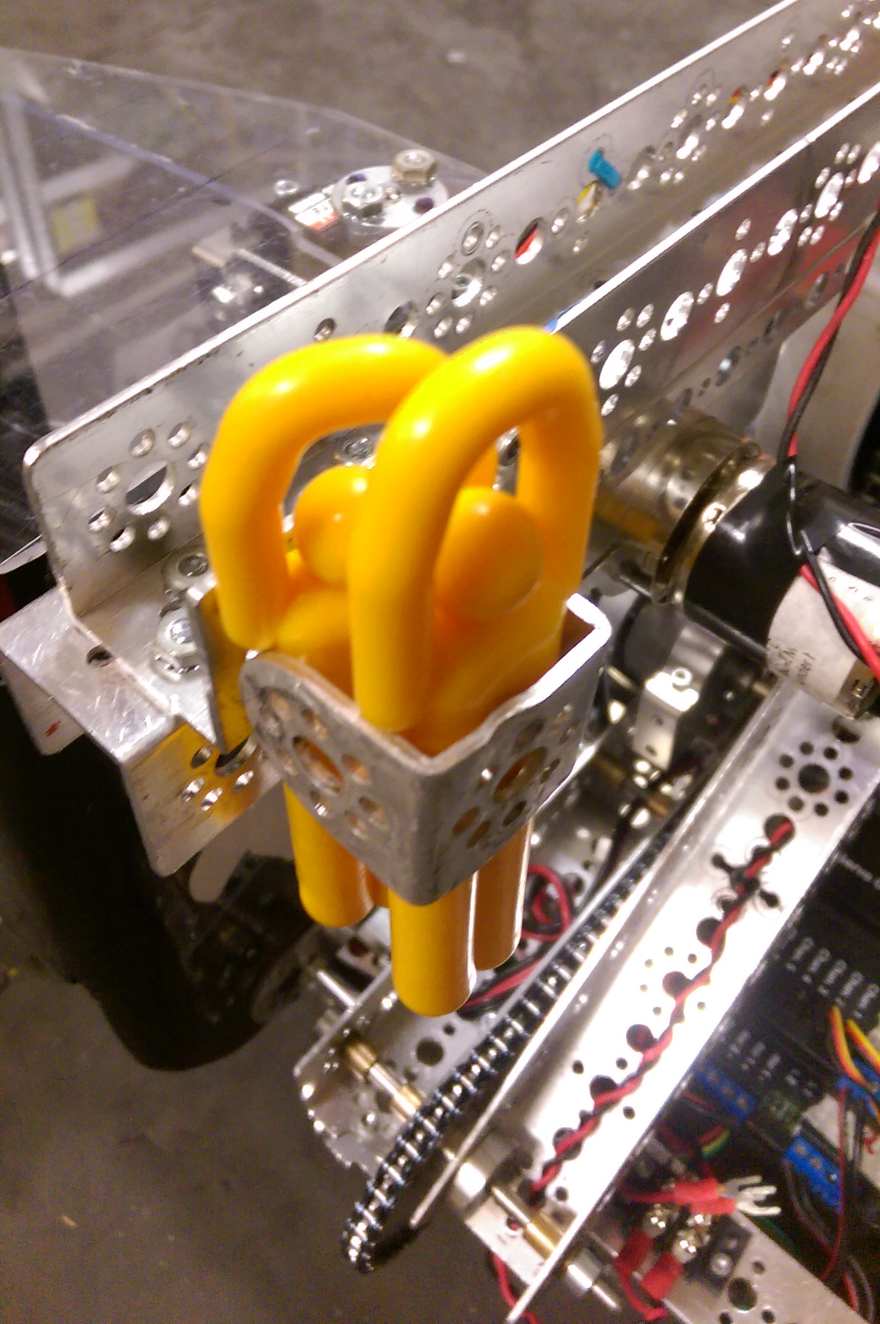
The Heart-break-er

The “Heart-Break-er” is a small part of our robot that can be used in autonomies, or in the teleop period. It is mounted on the end of the arm, and is used to hold and dispense the climbers. It is a simple Tetrix C-channel bracket that the climbers are placed into at the beginning of the match.
In autonomous period, the robot will maneuver over to the alliance light beacon, and use the arm to reach over the beacon and score the climbers in the bucket behind it.
If we choose to wait until the teleop period to score, dispensing the men is our first objective, followed by scoring debris in the other goals.



